Summary of Committee
Mission Statement and Goals of the Committee:
The purpose of the evaluation committee is to support 21CCLC grantees in measuring and reporting programs impact to better serve children and youth in Iowa.
Support is provided through reviewing national and state out-of-school time data, practical tools for data and outcomes reporting, and networking to share resources and support related to evaluation.
The committee strives to:
- Provide clear information and guidance on evaluation elements required for 21CCLC grantees.
- Keep 21CCLC grantees informed on any changes to required evaluation elements.
- Offer opportunities for feedback and input on required evaluation elements.
- Seek opportunities and solutions for reporting requirements that reduce burden on grantees.
- Develop templates and tools to support
- Share relevant and up-to-date best practices in evaluation and out-of-school time data.
- Promotes training and technical assistance related to your evaluation services.
Primary Contacts:
- Iowa Department of Education, Vic Jaras, vic.jaras@iowa.gov
  - Technical assistance, grant questions
- Iowa Department of Education, TBD
  - APR data system
- Ron & Rusty
  - cravey@rredcon.com
  - sinclair@rredcon.com
- IAA Staff-
  - Elva Griffin, egriffin@iowaafterschoolalliance.org
  - Heidi Brown, hbrown@iowaafterschoolalliance.org

- Committee Chair, Kaitlin Schmidt (St. Mark Youth Enrichment), kschmidt@stmarkyouthenrichment.org

Committee Expectations
The evaluation committee asks you to:
- Attend the bimonthly meetings. These meetings are held on the first Tuesday every other month (February, April, June, August, October, and December) at 9:00 am. The meetings are held via conference call or Zoom.
- The general focus of the meetings will be as follows:
  - February- Discuss needs to address in the year. Review past year and identify and areas to support: i.e. data collection, assessments, etc.
  - April- Review statewide survey
  - June- Statewide report discussion, Evaluation Timeline
  - August- APR/Templates
  - October- Local Evaluations- Ron/Rusty providing technical assistance
  - December- Communicating/disseminating evaluations and outcomes
- Participate in discussion. Your voice is important and we want you to feel comfortable asking questions and offering your opinions.
Please consider attending if you are seeking:
- To learn about best practices in evaluation
- To gain practical resources/tools to make evaluation easier
- To better understand the required evaluation elements as a new/newer grantee
- To offer support to the network because evaluation is an area of strength
- To provide input and suggest improvement to the required evaluation elements
- To have access to statewide data and outcomes

Overall Evaluation Requirements & Timelines
GPRA Measures:
The following measures are required to be reported on as stated in each grant agreement.
Additional local objectives will be reported on in the local evaluation but should be additive to the and not duplicate the GPRA Measures.
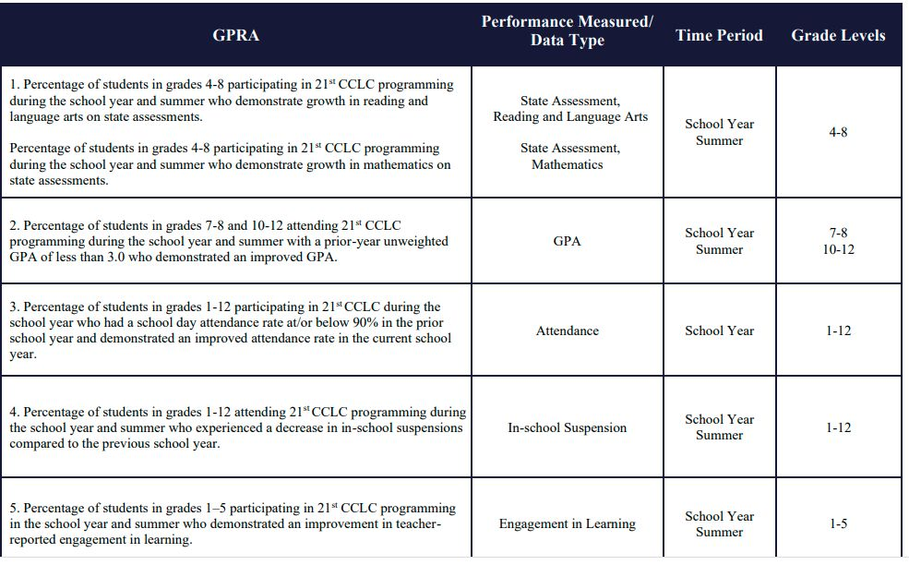

21 APR data entry:
Data entry in the 21 APR data system is required for each grant cohort, to be entered by each program location. The data entered into the 21 APR data system is for the most recent school year and summer from one year prior. For example for data being reported in fall/winter of 2022 you would report on the 2021-2022 school year and the 2021 summer.
Data entered into the 21 APR system includes partners, frequency and length of program activities by category, number of paid and unpaid staff by education level, student demographics, and attendance by hourly/weekly bands, and GPRA measure outcomes.
Data will be entered into two windows; the dates of the data entry windows are released annually and may vary year to year:
- Window 1: late June – early October; data includes program activities, staffing, and student participation
- Window 2: late October – early February, data includes outcomes.
- Data cannot be entered late. Once the windows close it will not be reopened.
- Be sure to click ‘submit’ for each section of the 21APR to have the data be recorded as completed.
- Templates to help with data entry are available on the 21CCLC website: https://www.iowa21cclc.com/grant-info under “Templates”.

Local evaluation:
ESSA 4202.3 ‘‘(C) Conducting a comprehensive evaluation of the effectiveness of programs and activities assisted under this part.”
ESSA 4203.14 ‘‘(C) public dissemination of the evaluations of programs and activities carried out under this part
The local evaluation report is an annual requirement of all grant cohorts. The local evaluation reports progress on the most recent school year and summer from one year prior (the same as the data reported in the 21 APR system).
Elements of the local evaluation include: program details, participant data/demographics, attendance, partnerships, parent involvement, measurement and discussion of GPRA measures, measurement and discussion of local objectives, anecdotal success stories and quotes, photos, sustainability plans, and recommendations and plans for future plans for change.
The local evaluation is due annually by November, 30th.
- Use only the provided local evaluation form, posted on the 21CCLC website: https://www.iowa21cclc.com/grant-info under “Templates”. The template is updated annually.
- Local evaluation training is held annually in early October to highlight any changes and provide information on best practices to complete the template. Local evaluator must attend the local evaluator training.
- Work with outside evaluator to assess program data, measure objectives, and provide recommendations for change. Further resources like local evaluator timelines, a template for a contract, recorded video trainings, etc. are found at https://www.iowa21cclc.com/grant-info under “Templates”. Additionally, contact information of evaluators open to work and have been used by current/previous grants are found on the same page.
- All data provided must match data entered into the 21 APR system.
- The local evaluation must be posted and accessible on website.
- Extensions are available by request. Email Vic Jaras to request extension.
Misc. data and reporting requirements:
There are additional data reporting and monitoring that require processes throughout the year. These require ongoing data collection processes. Templates are found on https://www.iowa21cclc.com/grant-info
- Community Partnership List, due September 30th: report of all active community partners by category.
- Professional Development log, due September 30th: report of all professional development by category.
- Statewide survey, due in January: survey to match 21 APR & local evaluation with number of students, programming information, professional development needs, etc.
- Anecdotal data, used throughout all reporting: collect ongoing input from all stakeholders.

General timeline:
A timeline with updated dates is posted annually on https://www.iowa21cclc.com/grant-info as “Grantee Timeline”.
Timeframe | Related Evaluation Process | Process
April-May | 21 APR  Local Evaluation | Collect assessment data and surveys
August-November | 21 APR  Local Evaluation | Work with local evaluator to assess program and GPRA measures
September | Misc. | Community partnership list due  Professional development log
September-October | Local Evaluation | Local evaluator training webinar
October | 21 APR | 21 APR window 1 due
November | Local Evaluation | Local evaluation completed and posted on website.
December-January | Misc. | State evaluator review, read, and aggregate local evaluations
January | Misc. | Statewide survey is due
January | 21 APR | 21 APR window 2 due

Evaluation Best Practice Guidance
Additional resources for best practices can be found on https://www.iowa21cclc.com/keywords/Data-and-Outcome-Measurement
Many templates are created to help with program evaluation on https://www.iowa21cclc.com/grant-info such as survey templates, evaluator contract templates, data collection spreadsheet templates, data sharing agreement templates, etc.

High quality evaluation includes:
- Is objective and recognizes any biases
- Following a timetable and work plan
- Focuses on both success and areas to improve
- Includes quantitative and qualitative measures
- All stakeholders and perspectives are included in survey efforts
- I able to be disaggregated to seek for any patterns within different populations
- Is shared transparently and publically

Objectives:
GPRA Measures will always serve as the official objectives. However, Local objectives allow grantees to focus on areas not covered by the GPRA Measures. Limit to 5 or fewer local objectives. Below are a few resources and best practices on creating objectives.

- Logic models can help determine what outcomes align with your programming.
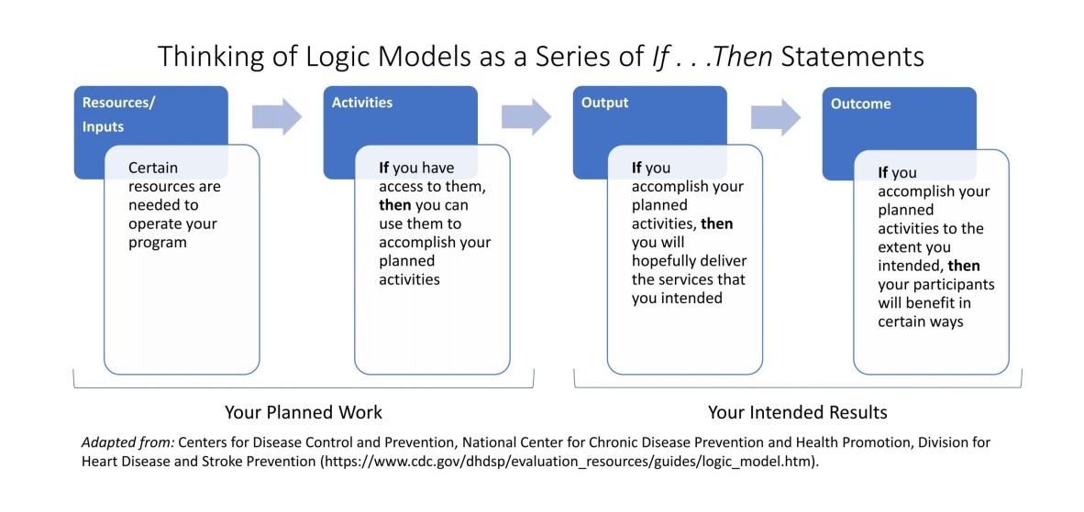
- SMART objectives are best practice.
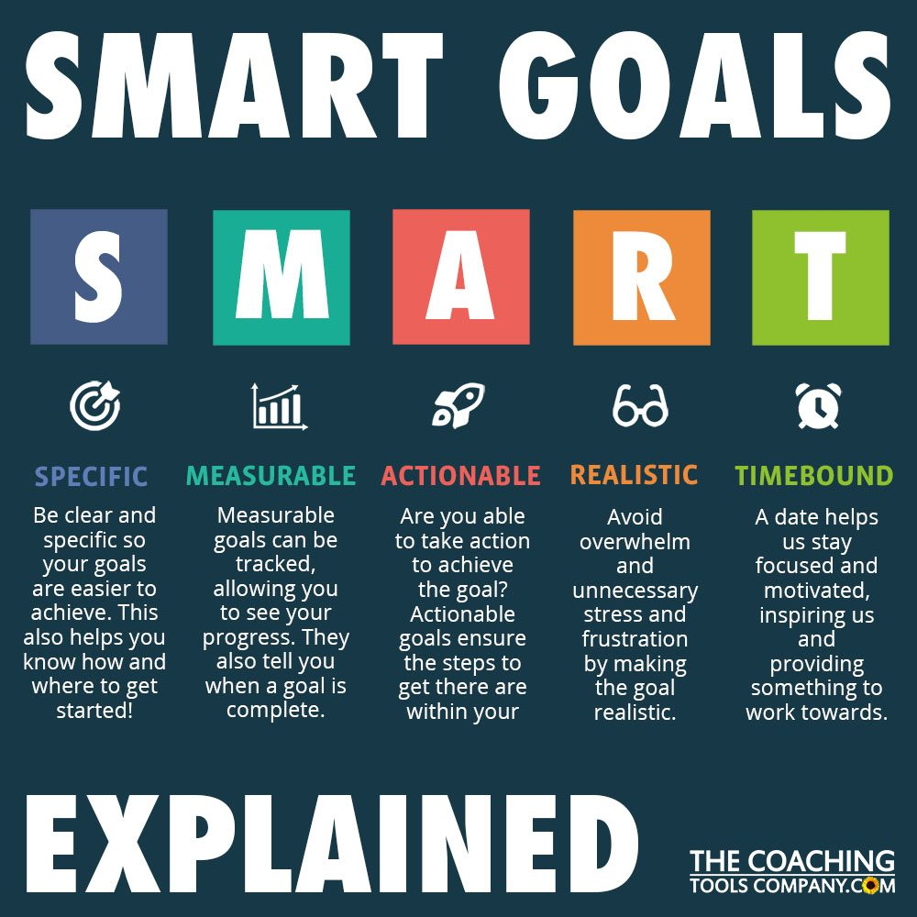

- Feedback on objectives is welcomed by Ron and Rusty (cravey@rredcon.com and sinclair@rredcon.com).
- Official amendments to objectives should be sent to Vic Jaras via email with explanations to changes.
Assessments:
- See the “Common Used SEL Evaluations” document posted on https://www.iowa21cclc.com/keywords/Data-and-Outcome-Measurement

Tips/Tricks/Hints from the field:
- Gathering, managing, organizing, analyzing, raw data (demographic, attendance, assessments results, surveys responses, etc.):
  - We utilize Cayen Data System- it tracks all of this information from the registrations of the students, we input attendance daily that is linked to activities.
  - Working in partnership with the data group at our district, we have developed a dashboard with all relevant information needed for reporting, with the exception of surveys. In order to make sure we are getting information from all parents, even those without access to technology, we provide paper surveys that are available in the family's preferred language.
- Capturing stories of impact and anecdotal success from the field:
- The site coordinator does a "monthly report" where she tries to enter daily a short summary of the day including any anecdotal or success stories. Our qualitative evaluator has done interviews which he records, then transcribes them and we can go through and pull quotes.
- We include an area on our monthly checklist that the site managers complete to share a success story from that month. They then get recorded in our Cayen Data System
- We try to collect these stories as they happen and are fresh in the minds of those working in our program.
- Work plans or tools to complete local evaluation, 21 APR, or other required evaluation elements:
- Simple spreadsheets, using the one our APR the committee has, an in-kind spreadsheet including parent and partner participation, and the monthly reports, etc. for anecdotal info.
- We have a website dedicated to our program where we store information. This allows for updates and documentation.

Additional Resources (Best Practices, Research, Links to articles):
- Annual state wide evaluations and data infographics
- Evaluation frameworks
  - Results Based Accountability
- Data visualizations and chart types resources
  - https://datavizcatalogue.com/
  - https://measuringu.com/summarize-survey/
- Dissemination- Using evaluation locally and leveraging outcomes for partnerships, other funding for sustainability.
  - Creating summarized outcome reports of local evaluation
    - Using tools like www.canva.com, Adobe express, etc.
  - Blogs and newsletters
  - Communications committee may be resource
- Statewide and National Data Resources
  - Iowa After School Alliance
  - After School Alliance
  - Attendance Works
  - Wallace Foundation
  - CASEL

