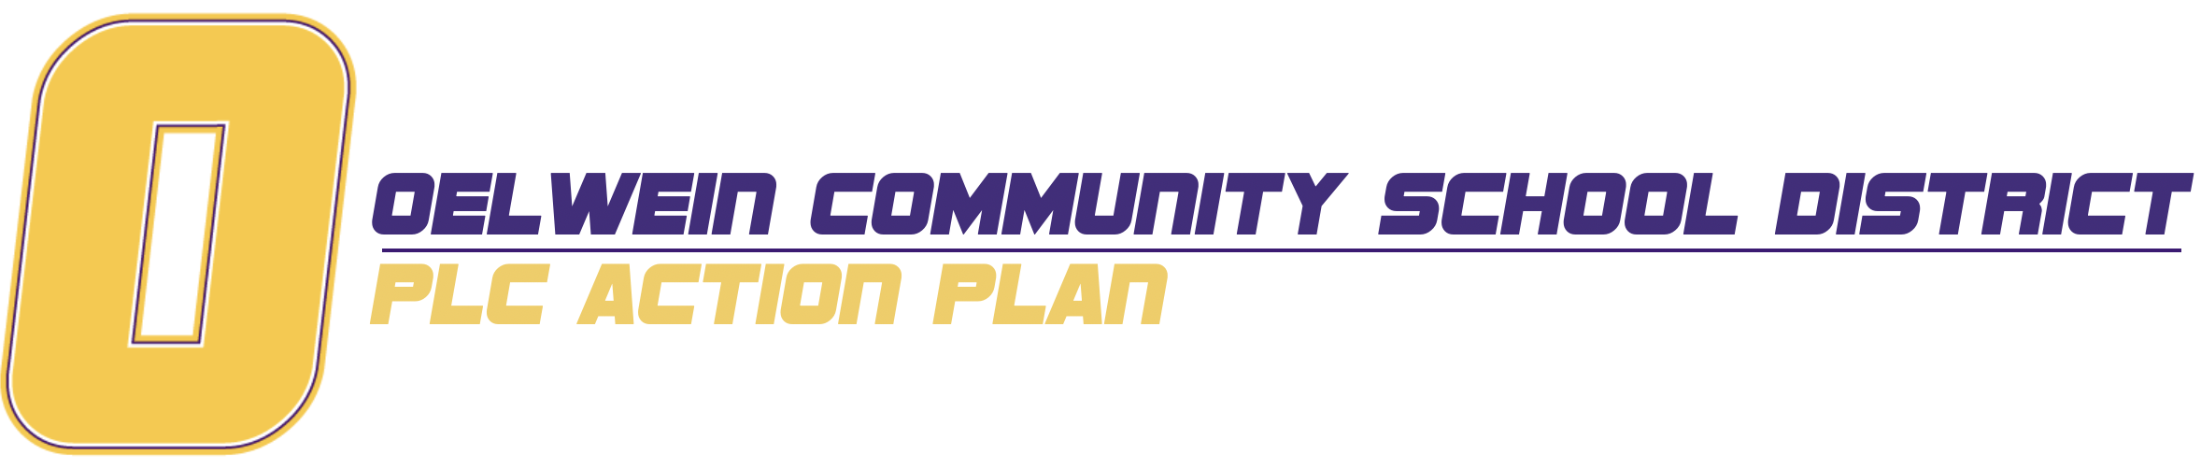
2021-22 School Year
GRADE LEVEL:
Connection to District Goals:

Connection to Building Goals:
OHS / OMS / Elem
Blended Learning:
Teacher Guide
PLC Norms:

Long Term Goal(s): | Small-Win Strategy #1:
 | Small-Win Strategy #2:
 | Small-Win Strategy #3:
 | Small-Win Strategy #4:
 | ADD A STRATEGY

Small-Win Strategy #1:
Planned Work, Activities, and Tasks  (practices and policies, infrastructure, technology, staff buy-in, marketing, role of teachers, professional development, and so on) | Resources Needed  (budget, materials, time, partnerships, and so on.) | Timeline | Person(s) Responsible | Evidence of Success

Small-Win Strategy #2:
Planned Work, Activities, and Tasks  (practices and policies, infrastructure, technology, staff buy-in, marketing, role of teachers, professional development, and so on) | Resources Needed  (budget, materials, time, partnerships, and so on.) | Timeline | Person(s) Responsible | Evidence of Success

Small-Win Strategy #3:
Planned Work, Activities, and Tasks  (practices and policies, infrastructure, technology, staff buy-in, marketing, role of teachers, professional development, and so on) | Resources Needed  (budget, materials, time, partnerships, and so on.) | Timeline | Person(s) Responsible | Evidence of Success

Small-Win Strategy #4:
Planned Work, Activities, and Tasks  (practices and policies, infrastructure, technology, staff buy-in, marketing, role of teachers, professional development, and so on) | Resources Needed  (budget, materials, time, partnerships, and so on.) | Timeline | Person(s) Responsible | Evidence of Success

