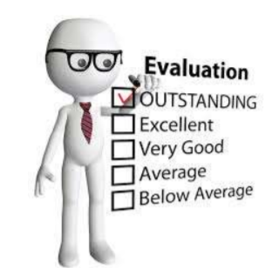
IOWA LOCAL EVALUATOR TIMELINE
Note: The local evaluation reports progress on the previous school year.
APRIL-MAY-Collect assessment data that is available. Visit school sites if that is part of your contract. Collect anecdotal data.
JUNE- JULY-All assessment data should be available to you.
AUGUST- Work on your reports ALL LOCAL EVALUATIONS MUST USE THE LOCAL EVALUATION FORM. You may add additional data, stories, analysis.
The APR system does NOT provide any reporting (except if the grantees enter data) so we are obligated to aggregate this data collection form. It has the additional benefit of showing local evaluators what data must be collected and will provide a consistent format for reporting on web sites.
Local evaluators can append additional analysis, local measures and other data to the local evaluation form.
SEPTEMBER- Local evaluations can be submitted now until November 30th
OCTOBER- NOVEMBER- Submit your local evaluations in electronic form (word or PDF).
NOVEMBER 30th - Local evaluations are due
Web Posting – It is required that all local evaluations are posted online for public view.
Make sure you provide a URL (web site address) along with your local evaluation. We put these into our state evaluation and they are collected and reviewed by the US Department of Education.
IF you need an extension, have the program director submit an email request with the reason why an extension is needed to: vic.jaras@iowa.gov
A 30 day extension is available, if needed. With an explanation, an additional extension may be granted.
DECEMBER- JANUARY- IDOE and the state evaluators will be reviewing, reading and aggregating data from the local evaluations to develop the Iowa State Evaluation.
FEBRUARY- MARCH New State Evaluation posted to IDOE website
MARCH- Local evaluators may be doing visits, having meetings or looking at data depending on their local contracts.
APRIL- Highlights of State Evaluation shared at Impact Conference with Program Directors HOW TO SUBMIT YOUR LOCAL EVALUATION- send an electronic copy (Word only) to: vic.jaras@iowa.gov
Federal requirements:
ESSA 4202.3 ‘‘(C) Conducting a comprehensive evaluation of the effectiveness of programs and activities assisted under this part.”
ESSA 4203.14 ‘‘(C) public dissemination of the evaluations of programs and activities carried out under this part;

