*Our students count on you to share your calm with them

* We need to regulate ourselves so we can co-regulate our students

*When we take care of ourselves, we take care of our students
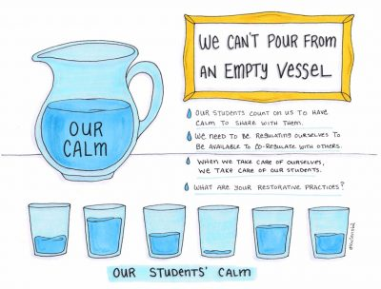
_____________________________________________________________________________________ Type in this Easy to find link: https://tinyurl.com/SLVCR
You will find on page: Sounds
Visuals
Games & Puzzles
Create
Mediation The Free Mindful Project

