Iowa 21st Century Community Learning Centers
Evaluation Committee
Meeting Agenda
June 7th, 2022
9:00AM

Join Zoom Meeting https://us06web.zoom.us/j/81167064154 Meeting ID: 811 6706 4154
----------------

COMMITTEE MISSION: This committee provides insight on state evaluation and resources around evaluation for programs and resources for sustainability. The committee reviews out-of-school time data, such as the annual Statewide Afterschool Report and provides input on the statewide survey for local 21CCLC programs.​

ROSTER

NAME | SITE/SCHOOL | MARK FOR ATTENDANCE
Kaitlin Schmidt | St. Mark Youth Enrichment | x
Amy Clair | Iowa City Schools
Dom Shirley | Des Moines Schools
Katie Boatright | Fairfield Schools | x
Chol Chagai | Clinton Schools | x
Beth Christoffer | Allamakee Schools
Elana Zalar | Council Bluffs Schools
Lynn Redenbaugh | Storm Lake Schools | x
Jenna Andrews | SHIP
Amy Whittington | Central Decatur Schools
Shaney Ford | Davenport Schools
Lisa Stevenson | Marshalltown Schools/MICA
Billy Stone | Oakridge Neighborhood Services
Jenny Becker | Kids on Course
Nikki Clausen | Council Bluffs Schools
Abby Kempema | SHIP

AGENDA ITEMS
Agenda Item | Notes
Evaluation Reminders: | Best practice webinar approaching, June 28th  Will share resources and templates for evaluation.
APR Windows | 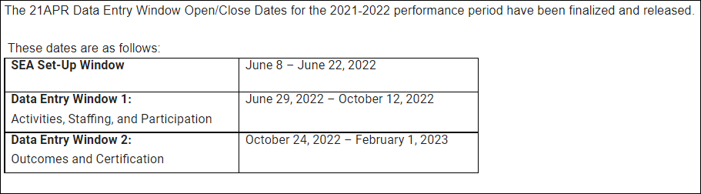
GPRA Best Practice Webinar: June 28th | Ideas on what content will be the most helpful?  Reviewing the APR system  Currently cannot login to APR system due to updates. Moving from 14 measures to 5 measures.  Vic will do overview at the webinar of the new system with screenshots of the new system included.  New grantees will be added and expired sites will be removed from the APR system.  Do a test-poll of data as a preview for the APR. This will be a transition year for us. Will practice looking at reports, sites will be more comfortable entering data.  If there is a new person in charge of APR at your site, please get information to Vic and Tim Glenn so APR permissions can be updated.
Committee Guide Review/Feedback | All the committees are doing a version of their own. A standardized version may be helpful.  Template was shared for review/feedback.  Committee guide will be helpful to provide structure to conversation. This will work well for the evaluation committee and potentially other committees as well.  Guide includes; best practice guidance, evaluation requirements, grantee timelines, etc. Will include APR system when it is completed. Will include guidance on Local Evaluation as well.  Vic – Local Evaluators are required to attend the training webinar. Especially important for this year as the measures will be changing. Will most likely happen in September of this year.  The local evaluation form will be completed this summer, the template will be updated and shared with sites by the end of July. Vic will send out when it’s completed.  This committee will continue to think about what guidance is necessary in the guide. Should include all the data pieces, how to gather them, and things that grantees may not think about before the evaluations are coming due.  A timeline table of note-able dates will also be included.  Statements and details about what a quality evaluation entails, GPRA measures, diversity in your local evaluation measures, all will be helpful pieces included in the guidebook.  Tips/Tricks portion of the guidebook will need more fleshing out – perhaps a survey from the grantee network will be helpful in this regard.  Will the resource library on the website continue to be relevant? After APR updates we may need to edit.  The one-pager of state outcomes from IAA should be included as an opportunity to share with funders and stakeholders. The communication, sustainability and partnerships committees are all also interested in collaborating on this. We may need a joint meeting on this topic to discuss.  Iowa is one of the few states that follow the federal guidelines for evaluation, drilling down to each individual grantee – showing how the local evaluations tie in.
Questions/Troubleshooting | Is next meeting scheduled in calendars?  Will survey current and new grantees for meeting dates and times moving forward.
Other | Thank you for your work on this Kaitlin! The document is comprehensive and will be very helpful to grantees.  The IAA will send out a formal survey to the network to collect input on survey participation moving forward for next school year.  Vic shared that the feds have hired the evaluator – Mathmatica – which has written a report in the past that was uncomplimentary of afterschool programs. He will watch closely to the organization and compilation of the evaluation, it may not show the full scope of afterschool programming (especially rural programs in Iowa) and the true benefit to students. ++

WORK PLAN

Deadline | Activity | Who’s Responsible | Outcome Expected | Notes for Implementation
Not set | Request for feedback from committee on guidebook | Kaitlin Schmidt | Comments and feedback from committee members to guide the work
August, 2022 | Survey to the network re: survey participation, timing, etc. | IAA | Information and feedback from grantees on committee participation

NEXT MEETING DATE: August 2nd, 2022
ADJOURN

