Compare and Contrast:
The Lorax

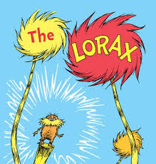
Activity Type: Literacy

Materials needed: The Lorax (book and movie)

Grouping: none

Time frame: book 35 - 45 minutes; movie 1hr. 45min.

Purpose: Youth will be able to recognize character personality traits within the storyline.
Youth will be able to identify and explain the similarities and differences between the book and movie.

Directions
- Discuss with the group the meaning of compare and contrast.
- Explain to the group that the next several days they will be comparing/contrasting the story of The Lorax.
- Staff or someone from the group will read. Stop reading at the end of “…Get over here fast! Take the road to North Nitch. Turn left at Weehawken. Sharp right at South Stitch.”
- Ask the following comprehension questions: Feel free to create your own questions.
-- Where could this story possibly take place?
-- Who is the Lorax? Possible answers: nature, world
-- Who does he represent? Possible answers: the earth, the animals
-- Who is the Once-ler? Possible answers: greed, harm
-- Who does he represent? Possible answers: the people, the world
- Continue to read. Stop at the end of “…Then we heard the tree fall. The very last Truffula Tree of them all!”
- Ask the following comprehension questions: Feel free to create your own questions.
-- What is the conflict between the characters (Lorax and Once-ler)?
-- Ask youth to predict the ending or they may write their own. If they have already heard the story, encourage youth to write their own ending. Or write an opposite ending from what happened.
- Optional --- continue reading story or let youth finish reading at another time. Now watch the movie, stopping it here and there to compare/contrast back to the book.

