DATA SHARING AGREEMENT

BETWEEN
[PROVIDING ORGANIZATION NAME] – School District
AND
[REQUESTING ORGANIZATION NAME] – This is you!

Purpose of Agreement
Describe the purpose of the data sharing agreement between the Providing Organization and Requesting Organization. Describe why the sharing initiative is necessary, objectives and benefits the Requesting Organization hopes to achieve. Example: This data sharing agreement will allow for the exchange of student data including but not limited to: academic grades and testing scores, proficiency and growth rates, attendance, and demographic data.

Duration of Agreement
Describe length of agreement between the Providing Organization and Requesting Organization.
Example: This agreement will commence on MM/DD/YYYY. This agreement will remain in place for XXXX (days/months/years/indefinitely) and will end on MM/DD/YYYY (if applicable) or until terminated by either party. Example: This agreement will commence on July 1, 2021 and this agreement will remain in place for three years and will end on June 30, 2024.

Description of Data
Describe the data being provided in this agreement. (Be specific – include variables names, descriptions, format, level of security/sensitivity.) Example: the Providing Organization will provide the following to the Requesting Organization twice per year on DATES. Data to be shared include: student grades, student attendance, etc. This data is to be provided in aggregate form to protect the identity of youth enrolled in the PROGRAM NAME.

Data Access
Describe how data will be physically transferred from the Providing Organization to the Requesting Organization. Include individuals or groups of individuals that will have access to the data. List the frequency data will be exchanged between the Providing Organization and Requesting Organization. Example: Data will be provided in a spreadsheet/Google doc/external flash drive/FORMAT YOU NEED. The Project Director and Program Managers at the Requesting Organization will have access to this data. Data will be shared twice per year on DATES.
Example:
Frequency: the information will be shared [each day/month/in response to a specific event]. The information sharing will cease [**]. The information sharing can be terminated by either party on written notice of [***]. The terms of this agreement remain binding on any information shared and retained throughout its lifecycle, irrespective of whether the party remains a current signatory to this agreement.
Transfer: will occur by [system to system transfer, Secure File Transfer, NHS Mail etc]. Information will be shared on a strict need to know basis only and the data will only be processed by staff in order for them to perform their duties in accordance with one or more of the defined purposes.
Under no circumstances should personal data be processed in any way that is unsecure or left unattended. It is the responsibility of the sender to ensure that the method is secure and that they have the correct contact details for the receiver.

Data Security
Describe security measures around transferring, accessing, and storing data. EXAMPLE: some sites have policies that require you to destroy the data after a certain amount of time.

Termination (of Agreement)
Describe how an organization will terminate services (verbal/writing, length of notice before termination), and what needs to happen once termination of services is provided by either organization (documents returned to Providing Organization or destruction of documents – deleted from hard drives, shredded, burned, etc. by Requesting Organization).

Signatures

[Providing Organization Name]

_________________________________
Signature

_________________________________
Printed Name

_________________________________
Title

_________________________________
Date
[Requesting Organization Name]

_________________________________
Signature

_________________________________
Printed Name

_________________________________
Title

_________________________________
Date

FERPA EXPLAINED FOR
THE NITA M. LOWEY 21st CENTURY COMMUNITY LEARNING CENTERS PROGRAM
The Nita Lowey 21st Century Community Learning Centers is a federal TITLE program (TITLE IV B) and districts or community groups apply for grant funding to operate an afterschool and/or summer program for at-risk children. As a federal program, we must follow all federal statutes and guidelines, which include The Federal Educational Rights and Privacy Act, the protects the privacy of student records.

What is the Family Educational Rights and Privacy Act (FERPA)?
The Family Educational Rights and Privacy Act (FERPA), 20 U.S.C. §1232g, is a Federal privacy law administered by the Family Policy Compliance Office (FPCO or Office) in the U.S. Department of Education. FERPA and its implementing regulations in 34 CFR part 99 protect the privacy of students’ education records.
Source- https://www2.ed.gov/policy/gen/guid/fpco/pdf/reasonablemtd_agreement.pdf
To Comply with FERPA and other Federal Requirements, the Superintendent and building Principal MUST sign an assurance written agreement that includes providing the data we need to report for this federal program (21st Century Community Learning Centers -TITLE IV B).
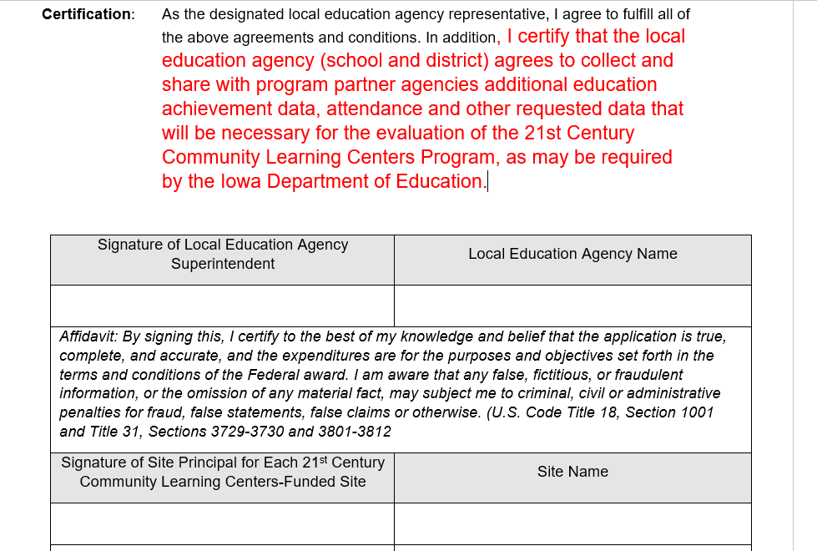

Our federal Title program by agreement (above) and provision in FERPA statute and other federal statutes has legitimate access to student identifiable academic data for federal reporting, audits and evaluation.
FERPA 99.35 provides the following:
(B) That the purpose for which the personally identifiable information from education records is disclosed to the authorized representative is to carry out an audit or evaluation of Federal- or State-supported education programs, or to enforce or to comply with Federal legal requirements that relate to those programs;
Source: https://studentprivacy.ed.gov/node/548/

Because we are diligent with protecting student privacy, we ask that the district data person or principal be the person who actually sees the student identifiable data. For our reporting, we only need aggregated program data for both federal reporting and evaluation.
WE NEED ONLY AGGREGATED DATA FOR OUR REPORTS- WE DO NOT REQUIRE ANY STUDENT IDENTIFIABLE RESULTS.
Starting in 2022, the data we report to the US Dept. of Education for this program will change. We must begin collecting this data in the summer of 2021 and the Fall of 2021 because we report about the previous school year, not the current school year.
Below is the data of the new data we have to collect for our program.

The program can supply the district with a list of student names who are participants and we will need the following data:
GPRA Measure 1- Percentage of Students in grades 4-8 participating in the 21stt CCLC program (school year and or summer) who demonstrated growth in Reading and English (Language Arts) on state assessments.
GPRA Measure 2-Percentage of students in grades 7-8 and 10-12 who attended the 21st CCLC program (school year and or summer) with a prior year unweighted GPA of less than 3.0 (grade of B) who demonstrated an improved GPA.
GPRA Measure 3- Percentage of students in grades 1-12 who attended the 21st CCLC program (school year only) who had a school day

FERPA EXPLAINED

attendance rate of at or below 90% in the prior school year and who demonstrated an improved attendance rate in the current school year.
GPRA Measure 4- Percentage of students in grades 1-12 who attended the 21st CCLC program (school year and or summer) and who experienced a decrease in in-school suspensions compared to the previous year.
GPRA Measure 5- Percentage of students in grades 1-5 who participated in the 21st CCLC program (school year and or summer) who demonstrated an improvement in teacher (or program staff) reported engagement in learning. This measure can be addressed via a teacher(staff) survey.
The Government Performance and Results Act (GPRA) of 1993 requires federal agencies to prepare a strategic plan covering a multiyear period and requires each agency to submit an annual performance plan and an annual performance report.
The US Dept. of Education has an online data collection site (APR- Annual Performance Report) where all 50 states report this program data annually and the national aggregated data is provided every year to Congress.
Therefore, it is critical that we have the cooperation of all stakeholders to provide the required data for this federal TITLE program each year.
Additionally, other federal statutes require recipients of federal funds to provide the required information when requested.
Edgar 200.336 (a) The Federal awarding agency, Inspectors General, the Comptroller General of the United States, and the pass-through entity (SEA), or any of their authorized representatives, must have the right of access to any documents, papers, or other records of the non-Federal entity which are pertinent to the Federal award, in order to make audits, examinations, excerpts, and transcripts. The right also includes timely and reasonable access to the non-Federal entity's personnel for the purpose of interview and discussion related to such documents

If you have any questions about the data requirements for the 21st CCLC program, please contact Vic Jaras, Consultant, Iowa Dept. of Education. Vic.jaras@iowa.gov

