Mouse Makes Words
By Kathryn Heling & Deborah Hembrook
Literacy Activity

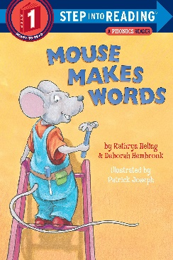
Activity Type: Literacy (K-2 grades)

Materials needed: set of alphabet letters, “Mouse Makes Words” by Kathryn Heling & Deborah Hembrook

Grouping: small groups 2-6 kids

Time frame: 20 - 30 minutes

Focus: Kids will be able to identify and formulate 3-letter rhyming words and make sound substitutions.

Directions
- Pass out to each individual kid a set of alphabet letters (A-Z).
- Instruct kids that this pile will be used to make rhyming words as you read the story.

Read “Mouse Makes Words” -----
- Before you read – talk about the title. Ask kids, what do you think this story is about?
- While reading -- have kids find and spell out the words using their letters. Give them time to do this assisting when necessary. Once kids have spelled out the second word allow for them to say the word.
--- For example (pgs. 10-11),
Staff reads: “Find the word FAN. Blow away the F. Move in a V.” Then ask kids, “Now what is the new word?”
Kids response: “VAN”
Staff reads: “Honk! Now it is VAN!”
- Continue reading through the story following the above example.
- Once done with the story, staff may continue the rhyming game using the additional words on the back OR have the kids come up with their own words.

